**Sbmitted By:**

2016-CS-115

2016-CS-155

2016-CS-172

**Submitted To:**

Sammyan Wahla

Medical Encyclopedia in Urdu

Table of Contents

**1.** **Introduction** 1

**2.** **Business Rules** 1

**3.** **Conceptual Design(ER Diagram)** 2

**4.** **Logical Database Design** 2

**5.** **Reports** 3

**6.** **Technology** 3

Table Of Figures

**Figure 1 ER Diagram** 3

**Figure 2 Database Diagram** 4

**CS-363L Database Systems**

**Term Project:**

**Medical Encyclopedia In Urdu**

# **Introduction**

The website of medical encyclopedia will provide information about the diseases. It has two users who are using their registered accounts. One is the Administrative user who is the doctor of the website. Other is the general user who can enter symptoms of the disease to get the information like treatment about the diseases. Doctor can add Disease’ Information and its related data which includes Symptoms, Reasons and Treatments of the diseases. Doctor can also update and delete the disease information. General user can enter the symptoms of the diseases and get the detailed information about the diseases. Both the doctor and the general users can generate the books in their desired pattern depending upon the information about the disease, its category and treatment.

# **Business Rules**

1. A disease has many treatments.
2. A treatment can cure many diseases.
3. A category has many treatments of a disease.
4. A disease has many symptoms.
5. A symptom can appear many diseases.
6. A category has many diseases.
7. A disease can occur in many categories.
8. A doctor can manage many diseases.
9. A disease can be managed by many doctors.
10. A general user has one profile only.
11. A doctor has one profile only.
12. A user has one account only.
13. An account can have 1 user only.
14. A doctor must have the license number associated with it.
15. A doctor can have only one license number that must be valid.
16. A User has a unique email8.
17. The doctor can add Disease and its related data.
18. An Administrative User can manage the categories.
19. An Administrative User can generate many books.
20. A general user can generate many books.
21. A user can generate many books related to the disease, treatment and category.
22. System can predict the disease depending upon symptoms.
23. The User Profile contains the data about the general user and doctor.
24. A doctor can manage many symptoms of the diseases.
25. A doctor can manage many treatments of the diseases.

# **Conceptual Design(ER Diagram)**

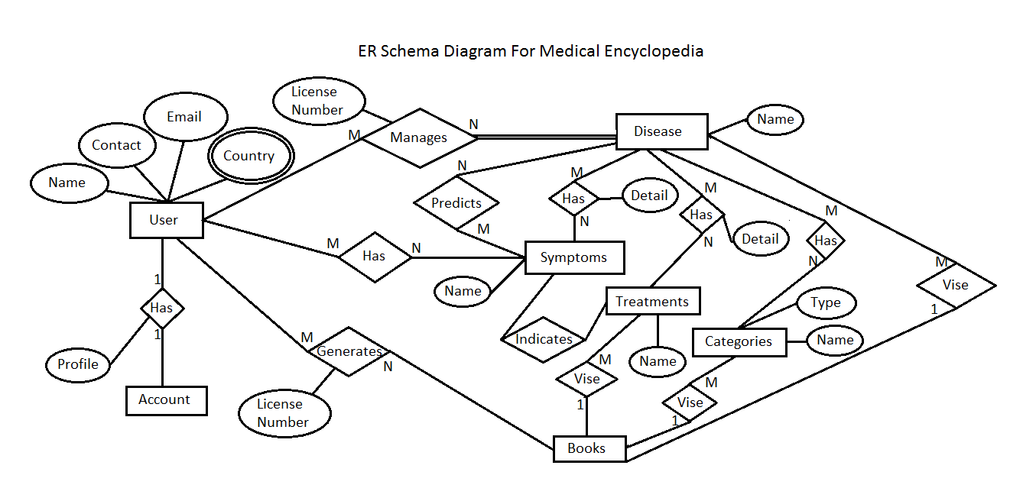

**Figure 1 ER Diagram**

# **Logical Database Design**

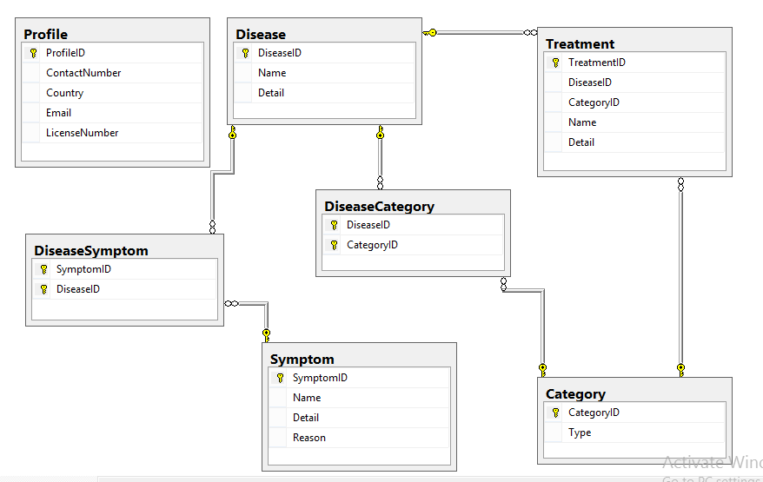

**Figure 2 Database Diagram**

# **Reports**

1. List of Diseases.
2. List of Category of Diseases.
3. Registered Accounts on the Website.
4. List of Doctors.
5. List of Administrative Users.
6. Symptoms of a disease.
7. Treatments of the disease.
8. Profile Information of the users.
9. Reasons of diseases.
10. Report of Disease Name, Symptoms, Category and Treatment together.

# **Technology**

* Microsoft Visual Studio 2015.
* Microsoft SQL Server 2014.
* Crystal Report.
* Web Application will be created.